**Lab1. System Admin2**

• Using Loop devices, create 4 PVs

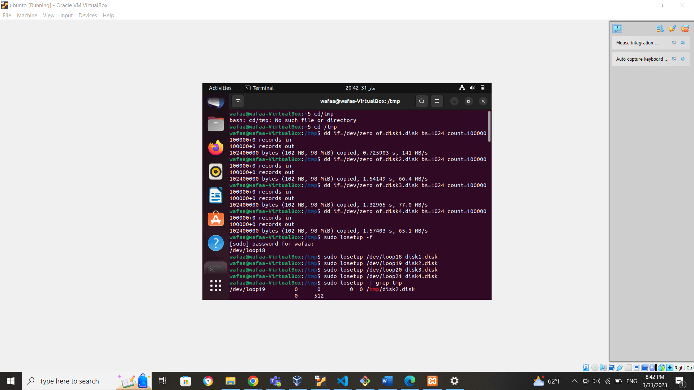

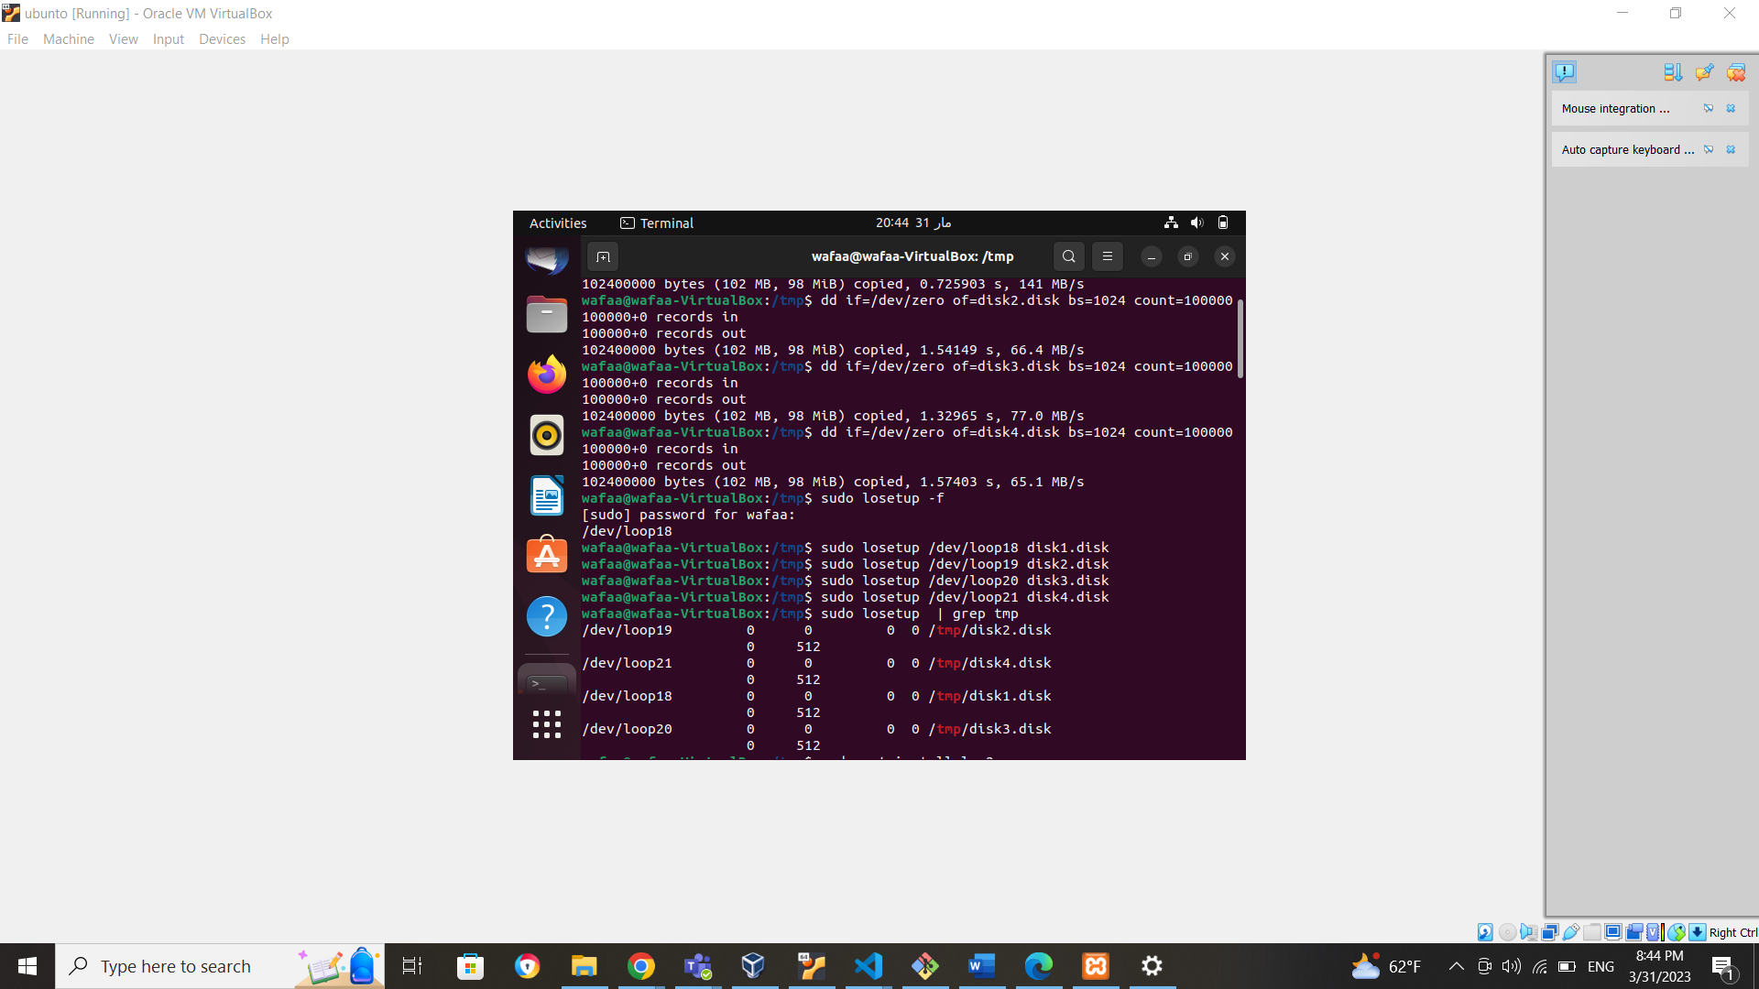

• create VG and add 3 on PVs to it

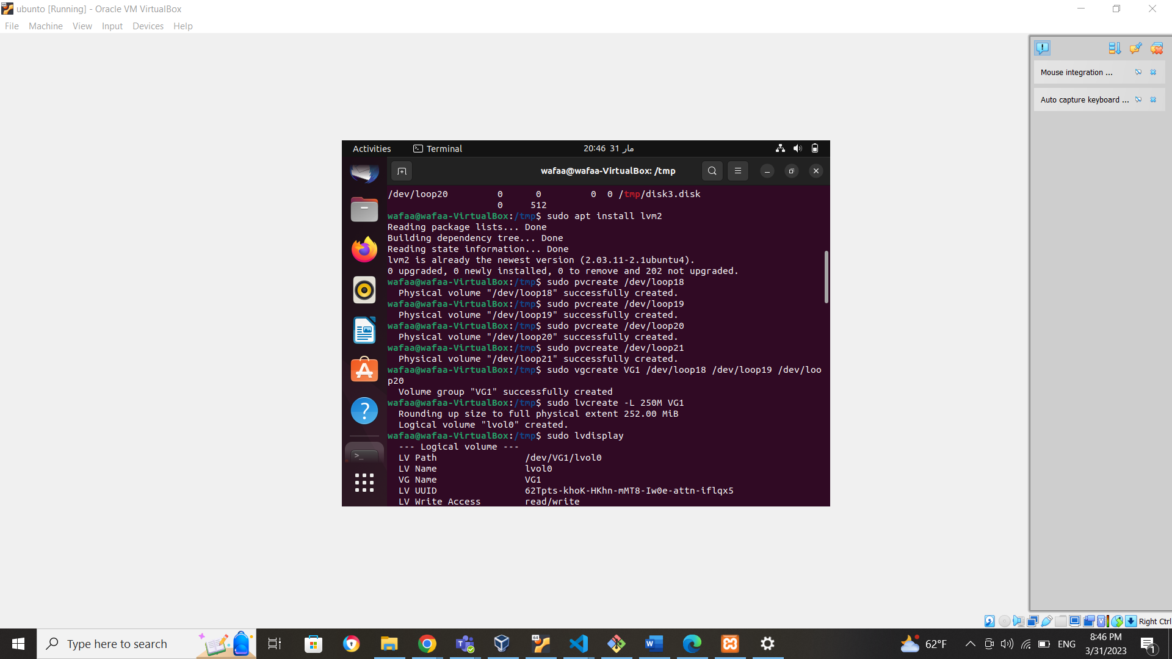

• create LV which has size of 250M

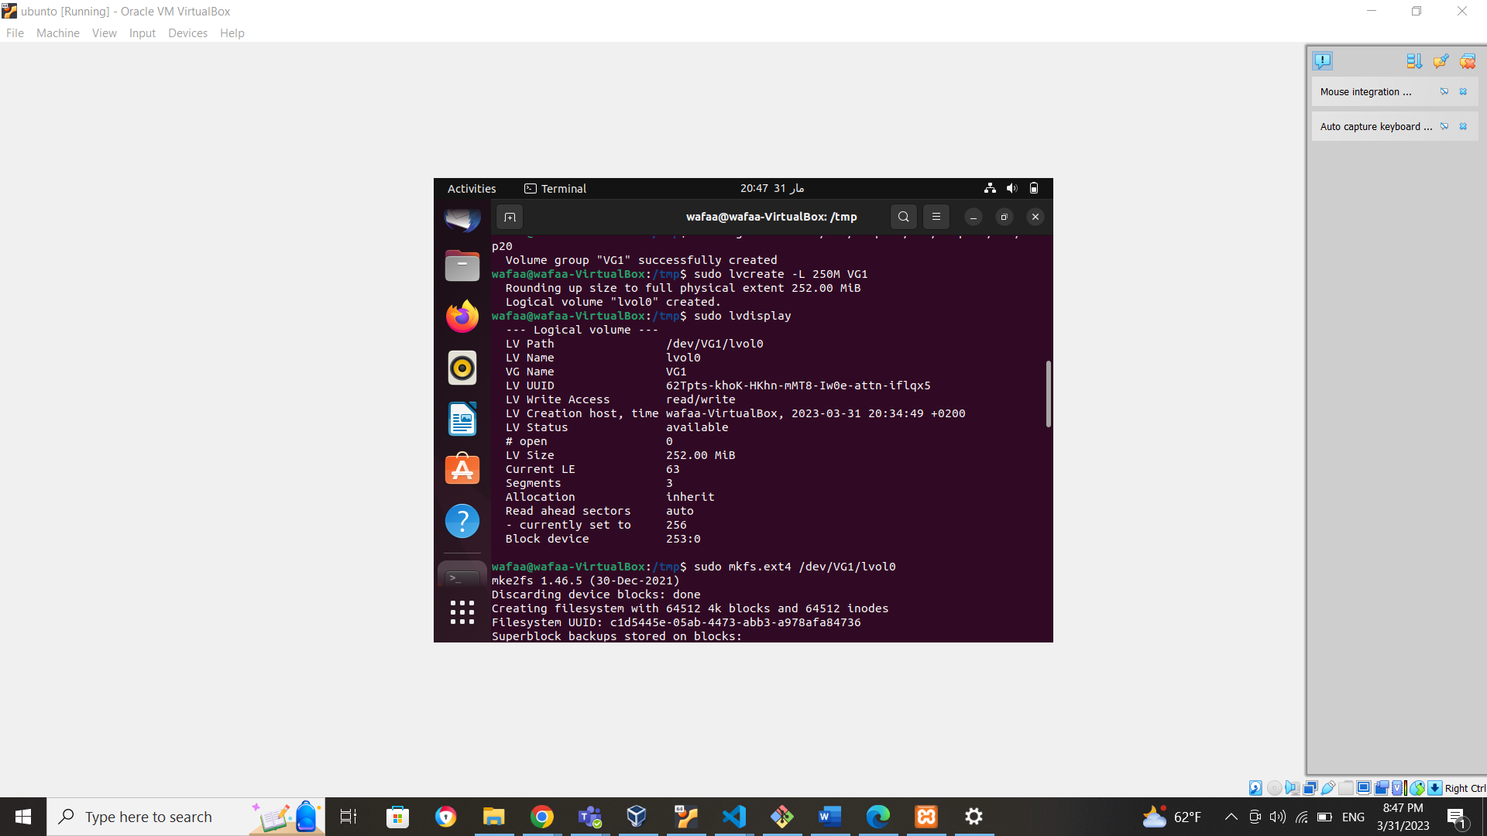

• format LV using ext4

• mount LV into /mnt directory

• extend VG with the remaining PV

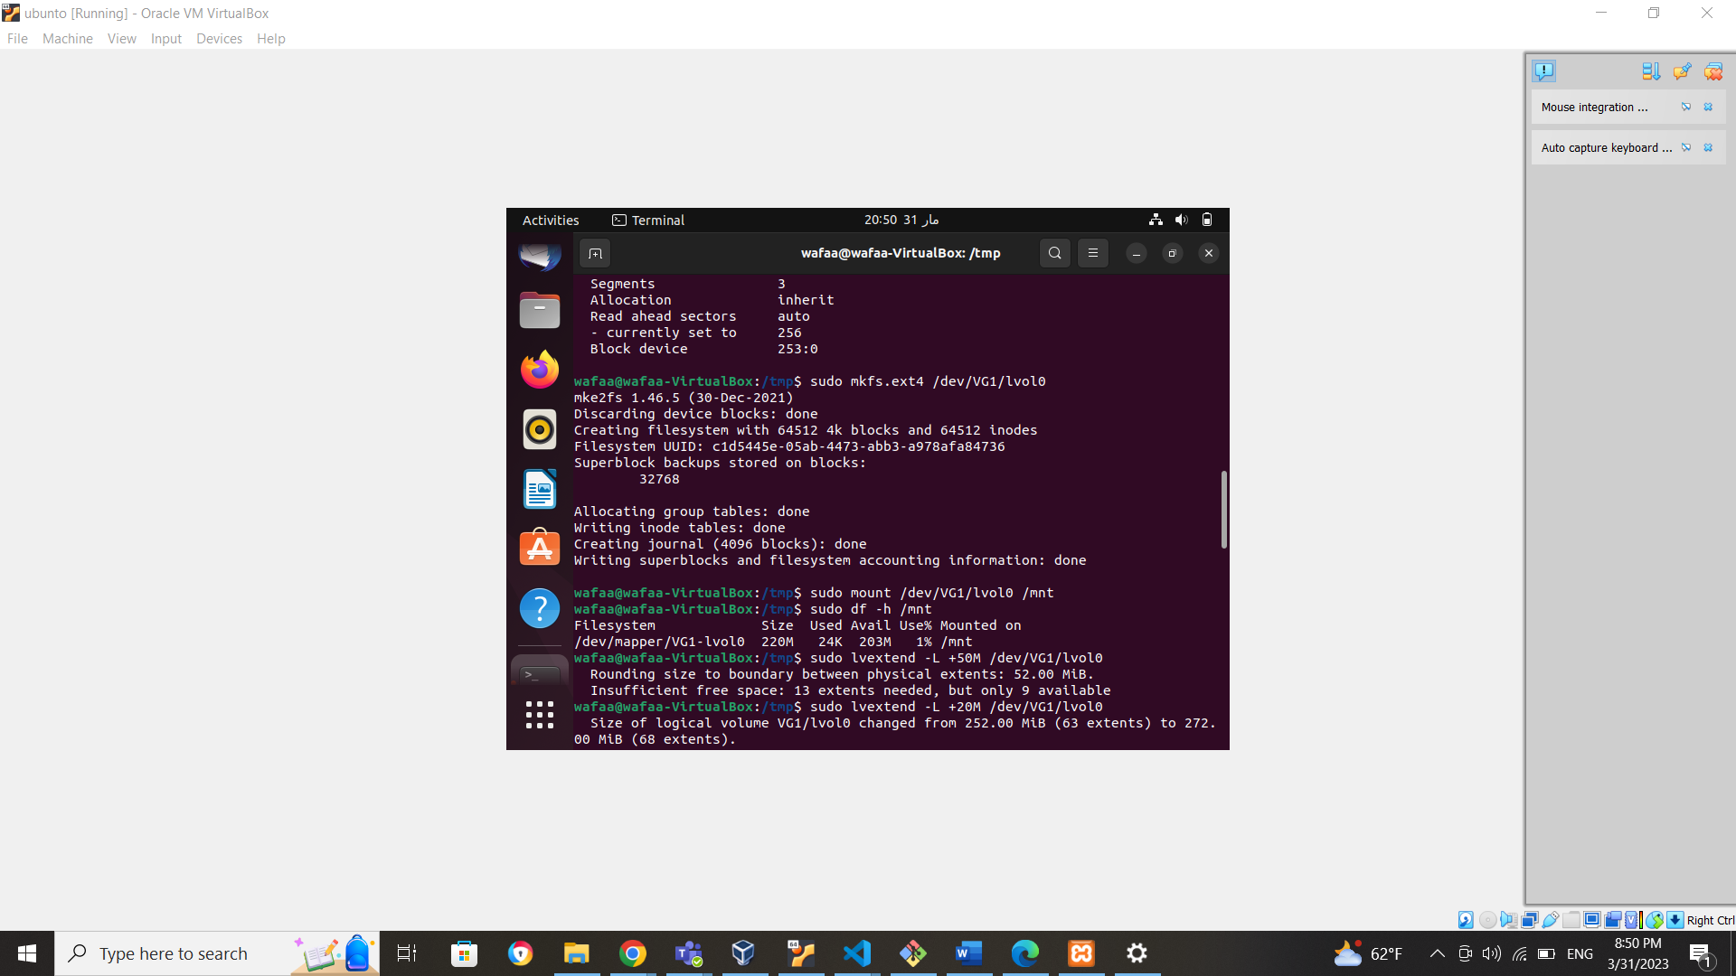

• extend LV with +50M

• resize2fs LV with the 50M extra

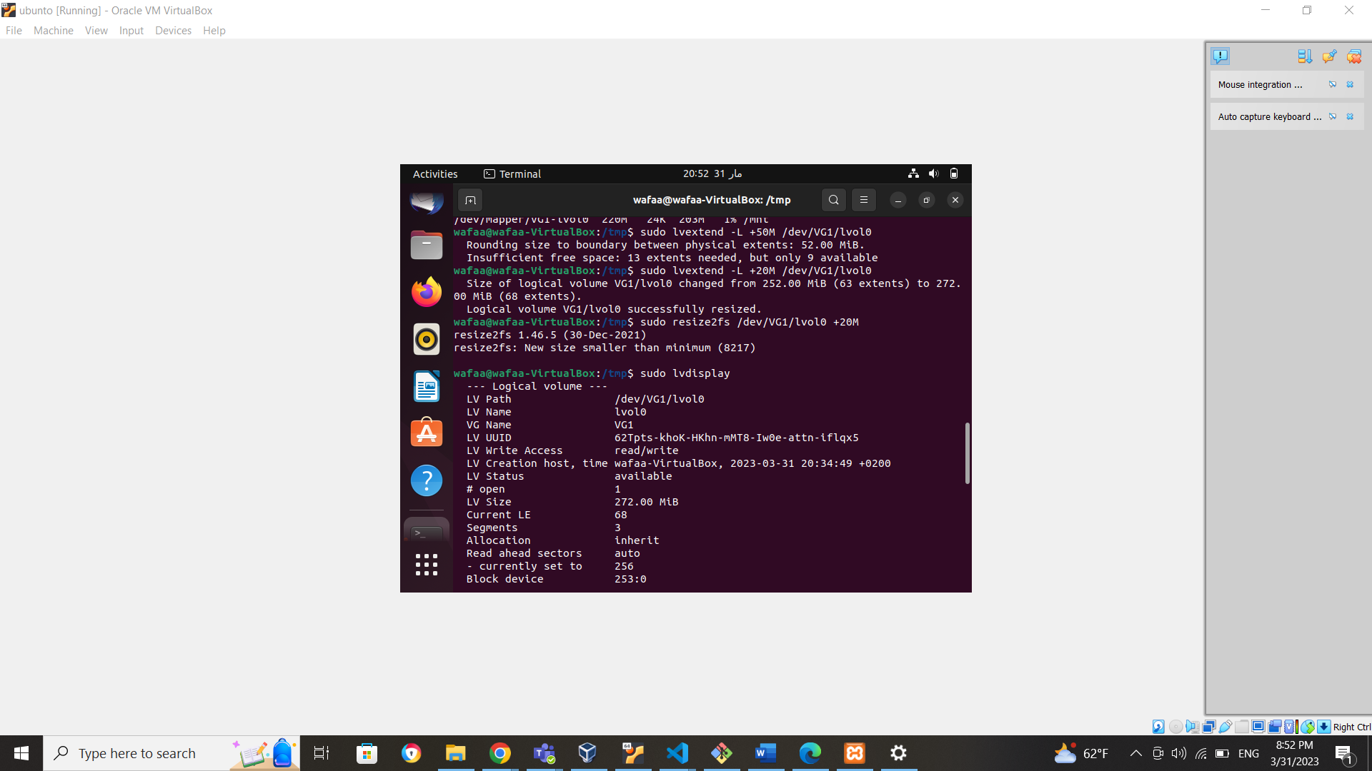

• Display the network interface information using ip command

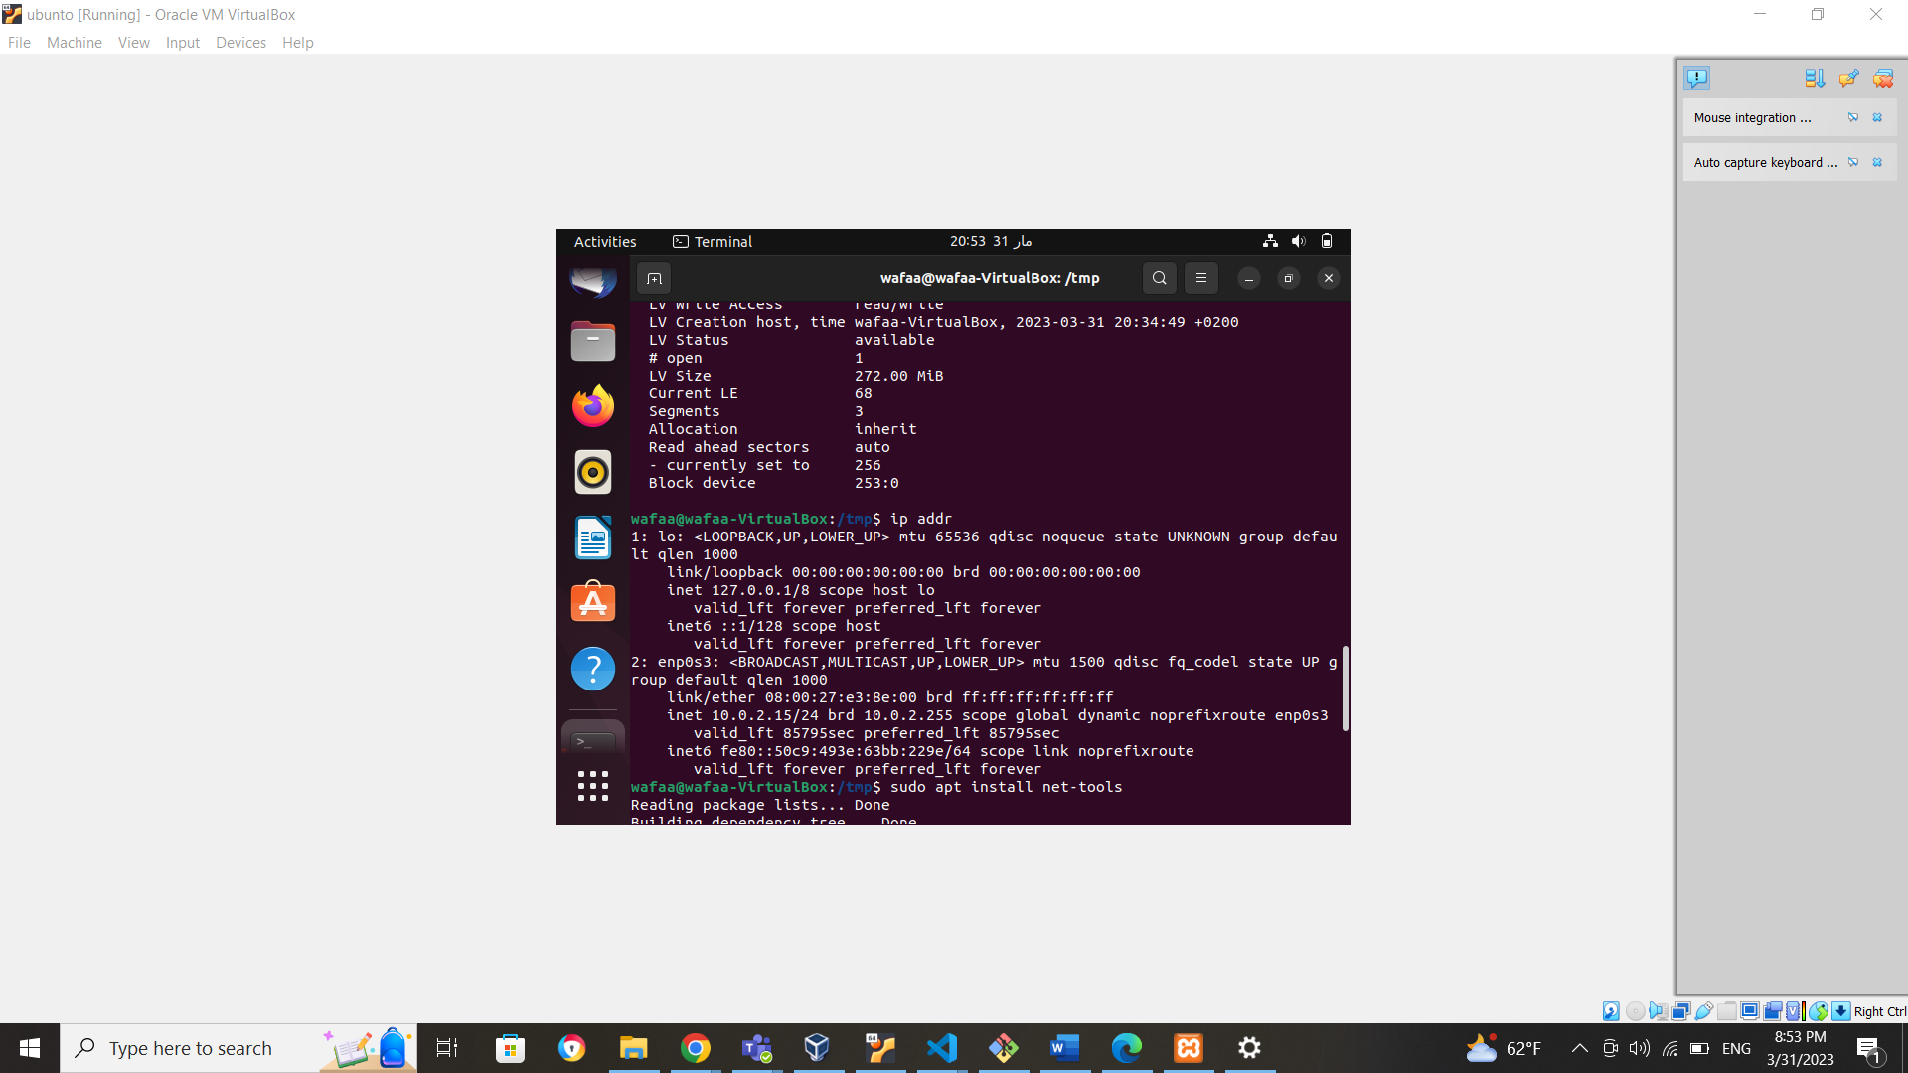

• Display currently active TCP connections on your OS using netstatcommand

• Display currently open ports on your system using nmap command (install it

using apt)

